GLOW LOGICS DIGITAL MARKETING A PROJECT ON

CUSTOMER JOURNEY MAPPING
Bachelor of Science in AI&DS
Ⅱ YEAR B.Sc – (AI&DS)
Submitted by,
S.ARAVINDH (Reg.No:12225050010)
DEPARTMENT OF SCIENCE
DHANALAKSHMI SRINIVASAN UNIVERSITY SCHOOL OF ARTS & SCIENCE
SAMAYAPURAM,TRICHY- 621112.
SEPTEMBER- 2026

A Study of an Online Brand: NYKAA

Academic Project Report

NYKAA

Prepared as a structured study of the customer journey from awareness to retention.

Project Details | Information
Topic | Customer Journey Mapping
Selected Online Brand | Nykaa
Journey Stages | Awareness → Consideration  → Purchase → Retention
Focus | Customer touchpoints, experiences, pain points and recommendations

TABLE OF CONTENTS
Project structure

No. | Section | Page
1 | Introduction | 1
2 | Selected Brand – Nykaa | 2
3 | Objectives &  Methodology | 3
4 | Customer Journey  Overview | 4
5 | Stage 1 – Awareness | 5
6 | Stage 2 – Consideration | 6
7 | Stage 3 – Purchase | 7
8 | Stage 4 – Retention | 8
9 | Pain Points | 9
10 | Recommendations | 11
11 | Detailed Journey Map | 13
12 | Key Findings | 14
13 | Conclusion &  References | 15

Note: The journey analysis is a structured academic interpretation of publicly available information about Nykaa’s digital customer experience. Specific customer emotions and pain points are analytical observations, not survey results unless stated otherwise.

Customer Journey Mapping – Nykaa
NYKAA CUSTOMER JOURNEY

Customer discovers Nykaa through advertisements, social media, search engines and recommendations
𝗍

Awareness → Customer becomes aware of Nykaa and its products

𝗍

Consideration → Customer searches for products, compares options, checks reviews, prices and offers
𝗍

Purchase → Customer selects a product → adds it to cart → completes checkout
→ makes payment → receives delivery

𝗍

Retention → Customer uses the product → receives customer support → engages with Nykaa again → may reorder products
𝗍

Pain Points & Recommendations → Improve product discovery → make comparison easier → simplify checkout → strengthen customer support → encourage repeat purchases

One-line explanation for each stage
Awareness → The customer first learns about Nykaa through social media, advertisements, search engines, beauty content or recommendations.

Consideration → The customer explores different products and compares price, reviews, ratings, features and offers before deciding.

Purchase → The customer selects a product, adds it to the cart, completes checkout and payment, and receives the order.

Retention → After purchasing, the customer evaluates the product and service experience. Good support, useful content, offers and convenient reordering can encourage future interaction.
Pain Points → Possible difficulties such as too many choices, comparison difficulty, checkout friction or post-purchase support issues are identified.

Recommendations → Nykaa can improve the journey through personalised recommendations, easier product comparison, simpler checkout, clearer information and stronger post-purchase support.

INTRODUCTION

Customer Journey Mapping is a marketing and service-design technique used to understand the sequence of interactions a customer has with a brand. It looks beyond a single purchase and examines what customers see, think, feel and do at different stages of the relationship.
For an online business, the journey can begin before a customer visits the website. A person may first notice a social-media post, a beauty tutorial, a search result, an advertisement or a recommendation from another customer. The person may then compare products, read reviews, check prices, add an item to the cart, complete payment and later decide whether to purchase again.
This project applies the customer journey framework to Nykaa, an Indian beauty and lifestyle company that began as a digital-first consumer-tech platform. Nykaa describes itself as an omnichannel beauty destination and states that it offers a wide range of beauty, personal-care and wellness categories through online and offline channels.
The study focuses on four main stages: Awareness, Consideration, Purchase and Retention. At each stage, the project identifies likely customer touchpoints, customer actions, expectations and possible friction. The final sections convert these observations into practical recommendations.

Why Customer Journey Mapping Matters

- It helps a company see the experience from the customer’s point of view.
- It connects marketing, website experience, purchasing, delivery and customer service.

- It highlights moments where customers may hesitate, abandon a purchase or need additional support.
- It provides a framework for improving consistency across digital and physical touchpoints.

SELECTED BRAND – NYKAA

Brand profile and digital ecosystem

Brand Background
Nykaa was founded in 2012 by Falguni Nayar as a digital-first consumer-tech beauty company. The company says its purpose is to make beauty more accessible and to provide consumers with curated, authentic products and services. Its current ecosystem extends across beauty, fashion and other related businesses.

Product & Service Categories

Area | Examples visible in Nykaa’s online ecosystem
Makeup | Foundation, concealer, lipstick, eye makeup,  palettes and tools
Skincare | Cleansers, serums, moisturisers, sunscreen and  masks
Haircare | Shampoo, conditioner, hair oil, serums and styling  products
Personal Care | Bath, body, grooming and hygiene products
Fragrance & Gifts | Perfumes, mists, candles and gift collections
Wellness | Health and wellness categories and related  products

Digital Experience Features
Nykaa’s public website includes product categories, brand stores, offers, beauty advice, Beauty Book, Nykaa Network and Routine Finder. These features create touchpoints not only for transactions but also for discovery and education.

Trust & Authenticity
Nykaa states that it has systems and processes intended to ensure product authenticity and describes its beauty and personal-care business as predominantly inventory-led, with sourcing from brands or authorised distributors in India.

OBJECTIVES & METHODOLOGY

Objectives
    - To understand the customer journey for an online beauty-shopping experience.
    - To identify the major touchpoints through which a customer interacts with Nykaa.
    - To map customer actions and expectations at Awareness, Consideration, Purchase and Retention stages.
    - To identify possible pain points that can interrupt the journey.
    - To provide practical recommendations for improving customer experience and retention.

Methodology
This project uses a secondary-research and analytical mapping approach. Publicly available information from Nykaa’s official website and company materials was reviewed to understand the brand’s categories, digital features, authenticity messaging and customer-facing services. The journey stages and pain points are then interpreted using standard customer-journey concepts.

Element | Approach
Research type | Secondary research + structured customer-journey  analysis
Brand selected | Nykaa
Primary journey | Online beauty-shopping journey
Stages studied | Awareness, Consideration, Purchase, Retention
Evidence base | Nykaa official pages and company information
Output | Journey map, pain points and recommendations

Scope & Limitation
The report is not a primary customer survey. Therefore, statements about customer emotions, hesitation and pain points should be treated as analytical hypotheses that can be validated later through interviews, surveys, website analytics, cart-abandonment data and customer-support records.

CUSTOMER JOURNEY OVERVIEW
Four-stage framework
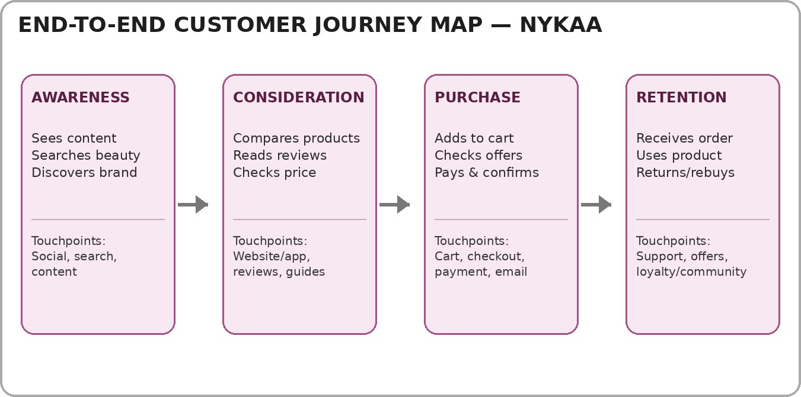

Stage | Customer Goal | Typical  Touchpoints | Desired Outcome
Awareness | Discover a relevant beauty solution | Social media, search, content,  recommendations | Interest
Consideration | Evaluate suitable  products | Product pages, reviews,  guides, filters, offers | Confidence
Purchase | Complete the transaction easily | Cart, checkout, payment, order  confirmation | Successful order
Retention | Get value and return when needed | Delivery, support, reviews, offers,  community | Repeat relationship

STAGE 1 – AWARENESS
How customers first discover the brand

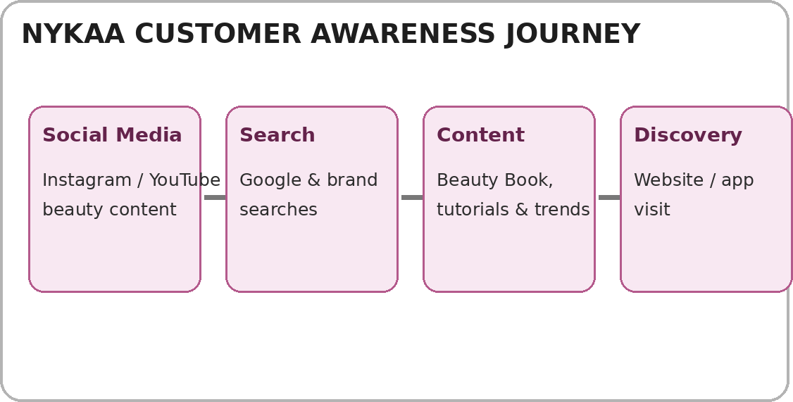

Customer Activities
- A customer notices beauty content, product demonstrations, trends or promotional communication.
- The customer may search for a product, brand or beauty solution and encounter Nykaa.
- Educational content can help move the customer from a general beauty need to a specific product category.
- The customer visits the website or app to explore products and brands.

Customer Expectations
At this stage, customers generally need clear information, relevance and a reason to continue exploring. Too much promotional content or unclear messaging can create attention overload. This is an analytical pain point to validate with actual customer data.

STAGE 2 – CONSIDERATION
How customers evaluate alternatives

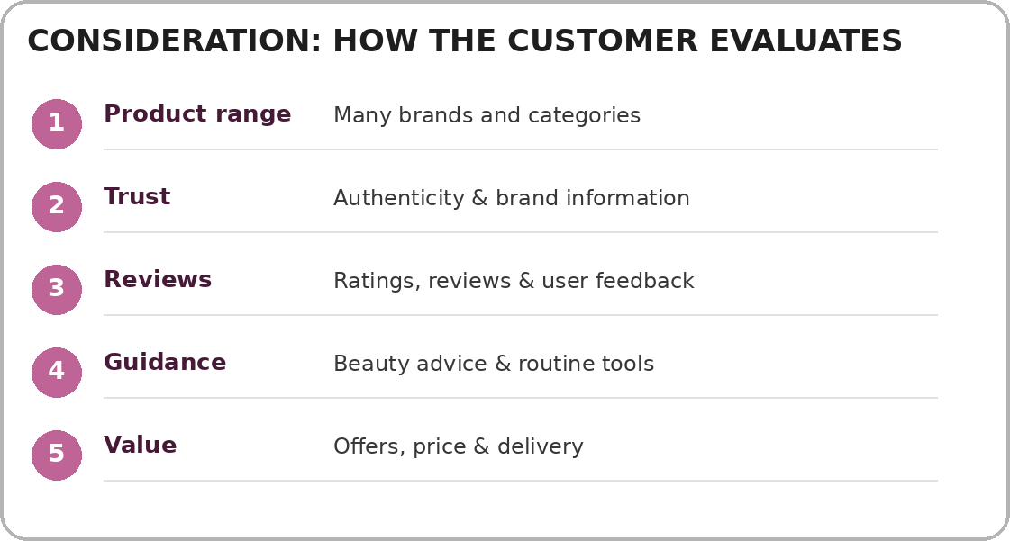

Key Consideration Factors
- Product relevance: Does the product solve the customer’s need?
- Trust and authenticity: Is the brand/product information credible?
- Reviews: What do other users say about the product?
- Price and value: Is the product within budget and are offers clear?
- Guidance: Can the customer understand how and when to use the product?
Nykaa’s website provides broad category navigation and beauty-advice resources, including Beauty Book, Routine Finder and Nykaa TV/Network features, which can support discovery and evaluation.

STAGE 3 – PURCHASE
From product selection to order confirmation

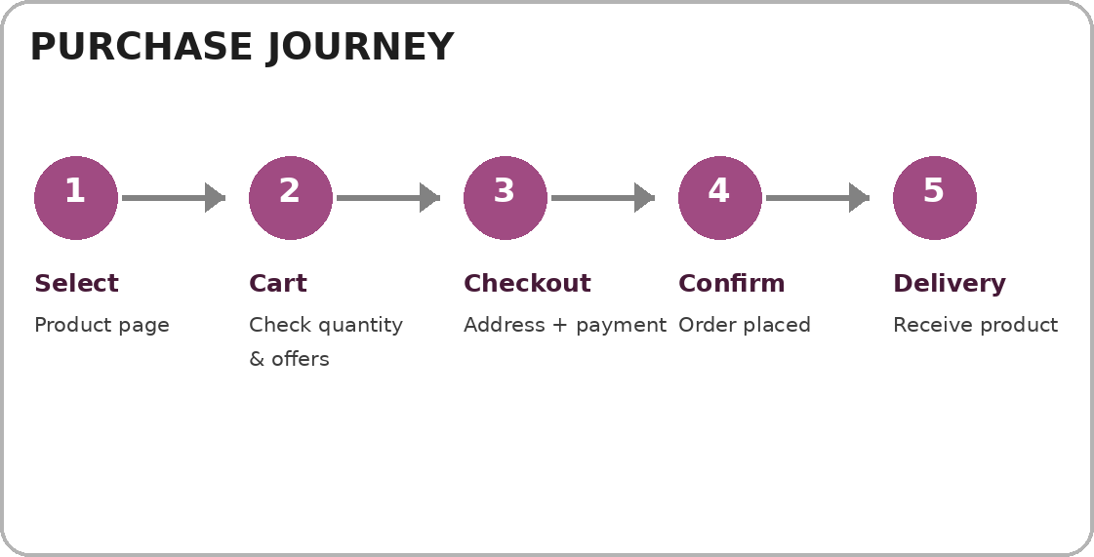

Purchase Touchpoints

Step | Customer Action | Experience Requirement
Product page | Checks images, price, details,  reviews | Complete and easy-to-scan  information
Add to cart | Chooses quantity/variant | Clear cart contents and pricing
Checkout | Enters address and chooses  payment | Low-friction form and  transparent costs
Payment | Completes transaction | Secure, reliable payment process
Confirmation | Receives order details | Clear confirmation and tracking  information
Delivery | Receives product | Accurate delivery and safe  packaging
Nykaa publicly describes secure transactions, payment options, delivery services and easy returns as components of its customer offering.

STAGE 4 – RETENTION
Turning a transaction into an ongoing relationship

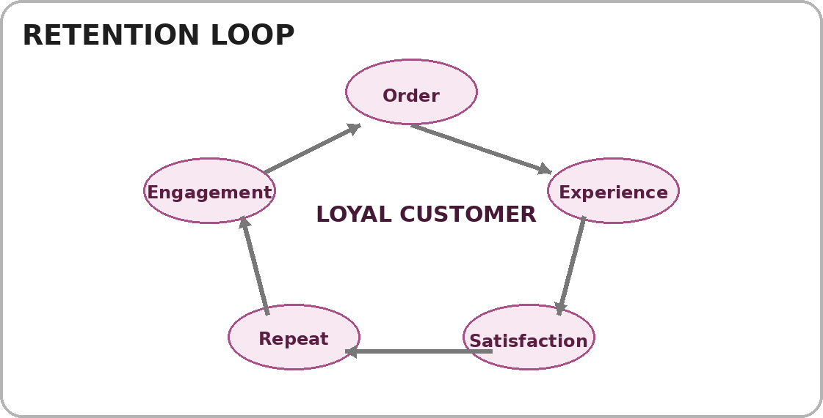

Retention Drivers
- Product satisfaction: The item should match the customer’s expectations.
- Delivery experience: Timely and accurate delivery supports trust.
- Customer support: Problems should be easy to report and resolve.
- Personal relevance: Recommendations and offers should reflect actual interests.
- Community and content: Helpful beauty education can bring customers back even before the next purchase.
- Repeat convenience: Saved preferences, order history and easy reordering can reduce effort.
Nykaa describes its online and offline ecosystem as combining commerce with content, expert-led advice and communities. Its official material also describes customer-first thinking and authenticity as important parts of its approach.

IDENTIFY PAIN POINTS
Possible friction across the journey

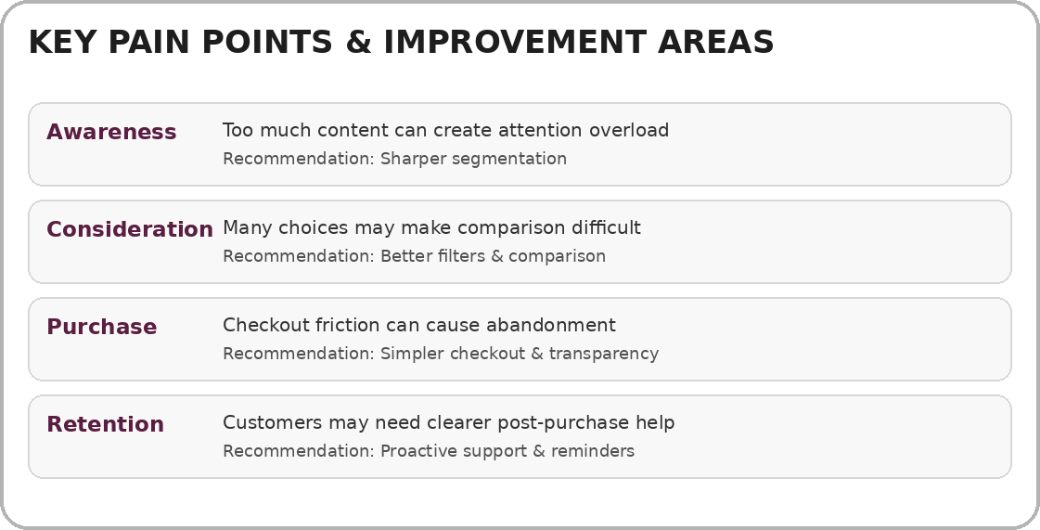

Detailed Pain-Point Analysis

Journey Stage | Potential Pain Point | Possible Customer Effect
Awareness | High volume of messages or promotions | Reduced attention / lower relevance
Consideration | Large assortment can make comparison harder | Decision fatigue
Consideration | Different products may have similar descriptions | Uncertainty about selection
Purchase | Unexpected cost or effort at checkout | Cart abandonment
Purchase | Payment or address errors | Transaction frustration
Retention | Difficulty getting quick post-purchase help | Lower confidence in repeat use

These are journey-design hypotheses rather than measured complaints. A business would validate them through customer interviews, survey responses, clickstream data, search data, checkout analytics and support-ticket analysis.

RECOMMENDATIONS

Improving the customer journey

Improve Personalised Discovery
Use customer-selected goals such as skin type, hair type, budget and product purpose to narrow discovery. Recommendations should remain transparent and easy to modify.

Strengthen Product Comparison
Provide a simple side-by-side comparison for similar products, showing price, size, key ingredients/features, ratings and suitability.

Simplify Checkout

Reduce unnecessary form fields, clearly show total cost before payment, and provide prominent delivery/return information.

Make Guidance More Actionable
Connect educational content directly to products, routines and usage steps so customers can move naturally from learning to shopping.

Proactive Post-Purchase Support
Provide clear order tracking, delivery updates, usage guidance and easy access to support after purchase.

Improve Repeat Purchase Convenience
Use reorder reminders based on product type and customer choice, while allowing customers to control notifications.

Close the Feedback Loop
Use reviews, support interactions and return reasons to identify recurring journey problems and improve product information.

Expected Benefits
  - Lower customer effort
  - Greater decision clarity
  - More transparent purchasing
  - Stronger post-purchase experience

DETAILED CUSTOMER JOURNEY MAP
Stage-by-stage experience analysis

Dimension | Awareness | Consideration | Purchase | Retention
Customer Need | Discover a solution | Choose the right  product | Buy with  confidence | Get value and decide to  return
Main Action | See/search/discover | Compare and evaluate | Cart → checkout →  payment | Use/support/review/rebuy
Touchpoints | Social, search, content | Website/app, reviews, guides | Cart, checkout, payment,  confirmation | Delivery, support, offers, community
Customer  Question | What is this? | Is this right for  me? | Can I buy  safely/easily? | Was it worth it?
Risk of Drop-  off | Low relevance | Choice overload /  uncertainty | Friction /  unexpected cost | Poor service / low  satisfaction
Improvement  Focus | Relevance | Clarity | Simplicity &  transparency | Support &  personalisation

Moment-of-Truth Concept
A moment of truth is an interaction that can strongly influence the next customer action. For an online beauty retailer, important moments include the first product discovery, reading reviews, checking the final payable amount, receiving the order and seeking help after purchase.

Journey Logic
The stages are connected. Strong awareness can increase qualified traffic; useful consideration tools can improve confidence; a low-friction purchase process can support completion; and a satisfactory post-purchase experience can create conditions for repeat engagement.

- KEY FINDINGS
Summary of the customer journey analysis
  - Nykaa’s digital ecosystem combines commerce with content, advice and community-oriented
  - The Awareness stage is primarily about relevance and discovery. Customers need a clear reason to move from content or search results into active exploration.
  - The Consideration stage is information-intensive. Product range, reviews, pricing, authenticity and guidance can all influence confidence.
  - The Purchase stage depends on a clear sequence: product selection, cart review, checkout, payment, confirmation and delivery.
  - The Retention stage extends beyond discounts. Product satisfaction, service quality, support, useful content and convenient reordering can all affect the relationship.
  - Because this project uses secondary research, the identified pain points should be validated with real customer data before implementation.

Suggested Metrics for Future Measurement

Stage | Possible KPI
Awareness | Reach, qualified traffic, branded search, content  engagement
Consideration | Product-page engagement, review usage, search  refinement, add-to-cart rate
Purchase | Cart-to-checkout rate, checkout completion,  payment success, delivery experience
Retention | Repeat purchase rate, reorder rate, support  satisfaction, review participation

These metrics can help connect the qualitative journey map with measurable business and customer-experience outcomes.

CONCLUSION & REFERENCES

Conclusion
Customer Journey Mapping provides a structured way to understand an online customer’s experience from first discovery to repeat engagement. In the Nykaa case, the journey is not limited to a transaction. Customers can discover products through digital content, evaluate alternatives through product information and reviews, complete an online purchase, and continue interacting with the brand through delivery, support, content and future shopping.
The four-stage map—Awareness, Consideration, Purchase and Retention—shows that each stage has different customer needs. Awareness requires relevance; consideration requires clarity and trust; purchase requires simplicity and transparency; and retention requires satisfaction, support and continued value. The recommended improvements therefore focus on reducing customer effort, strengthening product comparison, simplifying checkout, improving post-purchase support and making repeat shopping more convenient.
Overall, the journey map can be used as a practical framework for future primary research. Interviews, surveys, usability testing and digital analytics can be used to test the hypotheses identified in this report and determine which improvements have the greatest effect on customer experience.

References / Sources
  - Nykaa – Who Are We / The Nykaa Story: https://www.nykaa.com/who_we_are
  - Nykaa – Who Are We (2026 accessibility version): https://www.nykaa.com/who_are_we
  - Nykaa – Site Navigation / Categories: https://www.nykaa.com/right-nav-bar
  - Nykaa – Sitemap / Product and service categories: https://www.nykaa.com/sitemap-app
  - Nykaa – Official site / customer service and shopping information: https://www.nykaa.com/ss
  - FSN E-Commerce Ventures Ltd. – Integrated Annual Report 2024–25 (official Nykaa investor material).

End of Project Report

